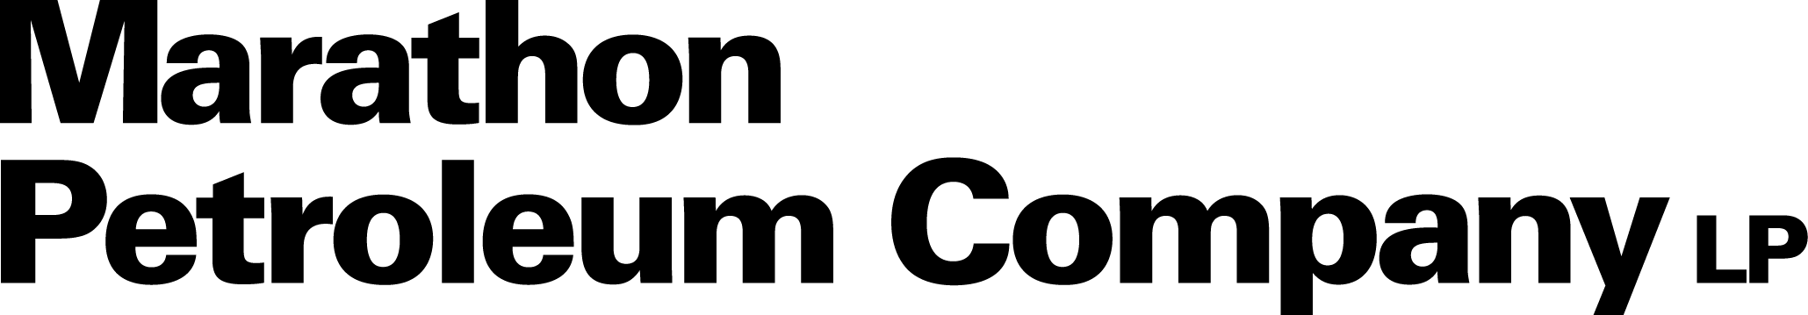

Value Tracking Automation (VRMS)
Value Realization for Value Chain Optimization
Technical Design Document

Document Version | 1.0
Date | September 2026
Client | Marathon Petroleum Company LP
Prepared By | Proclink Consulting Services LLP
Status | Draft for Review
Classification | Confidential
Prepared by


Document Revision History
Version | Date | Author | Reviewer | Description / Change
1.0 | September 2026 | Proclink Delivery Team |  | Initial draft for review
Document Approval Log
Role | Name / Position | Signature | Date
Prepared by | Proclink Delivery Team
Reviewed by
Verified by
Approved by

Table of Contents

1. Technical Overview

1.1 Introduction
Marathon Petroleum Company LP (MPC) is undertaking a Value Chain Optimization (VCO) transformation to improve operational efficiency, enhance decision-making, and standardize value realization across its operations. As part of this initiative, the Value Record Management Solution (VRMS) — the Value Tracking Automation capability — operationalizes MPC’s approved Value Realization framework through a controlled, supportable, and auditable digital capability built on the Microsoft Power Platform.
This Technical Design Document (TDD) defines the technical architecture, environment configuration, data model, application configuration, workflow (cloud flow) configuration, AI-assisted classification design, reporting enablement, security and access design, monitoring, deployment, testing, and transition for VRMS. The functional and solution-level design is documented separately in the VRMS Solution Design Document (SDD).
The concrete implementation pattern for the core value-record lifecycle — submission, automated validation, approval routing, and status notification — is established by the VRMS Proof of Concept (POC) built on Power Apps (Canvas App), Power Automate (Cloud Flows), and a SharePoint Online list. This document uses the validated POC pattern as the technical baseline and extends it to the full Base-Scope solution. Full-build elements that are subject to Company approval at Gate 1 are identified as such or marked TBD/To Be Confirmed where the source requirements are not yet finalized.

1.2 Objectives
The primary technical objectives of VRMS are:
- Enhance the existing RVCO Commercial Value Add SharePoint solution into an automated, governed value-tracking capability on SharePoint Online, Microsoft Lists, Power Apps, Power Automate, Microsoft Entra ID, approved AI capabilities, and Power BI enablement.
- Implement a value-record data model, role-based application experience, and deterministic cloud flows for validation, approval routing, notification, and status management.
- Provide AI-assisted classification integrated with the form and controlled vocabularies, subject to confidence scoring, human review, and override.
- Deliver reporting-ready data structures, mappings, KPI/measure specifications, reconciliation logic, and Row-Level Security requirements for Company-owned Power BI reporting.
- Apply role-based access, segregation of duties, least-privilege service identities, monitoring, and audit history consistently across the platform.
- Establish environment, deployment, source-control, monitoring, and support practices that make the capability maintainable and auditable.

1.3 Business Context
MPC records VCO value events in the RVCO Commercial Value Add SharePoint list, while subsequent validation, reconciliation, allocation, workflow, and reporting activities remain partially manual or are completed through separate tools. VRMS automates and strengthens value capture, validation, calculation, allocation, review, approval, reconciliation, reporting enablement, administration, and auditability, while preserving required human review and decision authority. Neither deterministic automation nor AI-assisted functionality may independently approve, endorse, certify, or publish a value record.

1.4 Reference Documents
Document Name | Version | Description
SOW BK082026 — Value Tracking Automation | — | Statement of Work: scope, deliverables, responsibilities, schedule, fees, assumptions, exclusions, and acceptance criteria.
VRMS Technical Implementation Guide for POC | 1.0 | Step-by-step build guide for the value-record lifecycle POC (Power Apps + Power Automate + SharePoint Online).
VRMS Reference Architecture Diagram | 1.0 | Conceptual Power Platform reference architecture for the solution.
VRMS Solution Design Document | 1.0 | Companion solution and functional design document.
Company Value Methodology & Calculation Framework / Governance & Cadence Framework | — | Company-approved business baseline for calculations, allocations, and governance.
Table 1: Reference Documents

2. Solution Approach
This section describes the overall technical approach for VRMS. The solution is a layered, low-code Microsoft Power Platform solution built on SharePoint Online, in which the application, automation, AI-assistance, and reporting-enablement concerns are configured and secured independently and integrated through standard connectors and Microsoft Entra ID identity.

2.1 Solution Overview
Users authenticate with Microsoft 365 / Microsoft Entra ID and interact with a Power Apps canvas application. The application reads and writes value records to SharePoint Online lists that serve as the operational system of record. Power Automate cloud flows implement deterministic automation — validation on submission, approval routing, notification, and status management. AI-assisted classification is integrated with the value-record form and controlled vocabularies to recommend approved classifications and calculation references. Power BI consumes reporting-ready data derived from the SharePoint lists to deliver dashboards and KPI monitoring, built and published by Company Dashboarding.

2.2 Platform Architecture
VRMS follows a low-code, service-integrated architecture on the Microsoft Power Platform. The design favors standard (non-premium) connectors and native SharePoint/Power Platform capabilities to remain within the approved Base Scope. Azure SQL, Dataverse, new SharePoint hubs, department-specific sites, Content Type Hubs, premium connectors, custom connectors, external hosting, or supplemental data platforms are implemented only if Company approves the applicable architecture, security, commercial, licensing, data, migration, and support implications.
Technology Layer | Technology / Tool | Purpose
Identity & Access | Microsoft Entra ID | Authentication and authorization; security groups mapped to approved roles and personas.
Presentation | Power Apps (Canvas App) | Value-record creation, work queues, review/approval, and administration.
Operational Data | SharePoint Online, Microsoft Lists | Operational system of record for value records, reference data, evidence, and audit history.
Automation & Rules | Power Automate (Cloud Flows), Approvals connector | Validation, approval routing, notification, status management, escalation, and exception handling.
AI Assistance | Company-approved AI service (integrated with form & controlled vocabularies) | Recommends approved classifications and calculation references with confidence and explanation.
Notifications | Office 365 Outlook / Microsoft Teams connector | Approval requests, reminders, escalations, and outcome notifications.
Reporting | Power BI Desktop, Power BI Service, Power BI RLS | Interactive reports, dashboards, and KPI monitoring on reporting-ready data.
Monitoring | Power Automate run history, connector/flow analytics | Flow health, error monitoring, and audit support.
Table 2: VRMS Technology Stack

2.3 Technical Architecture
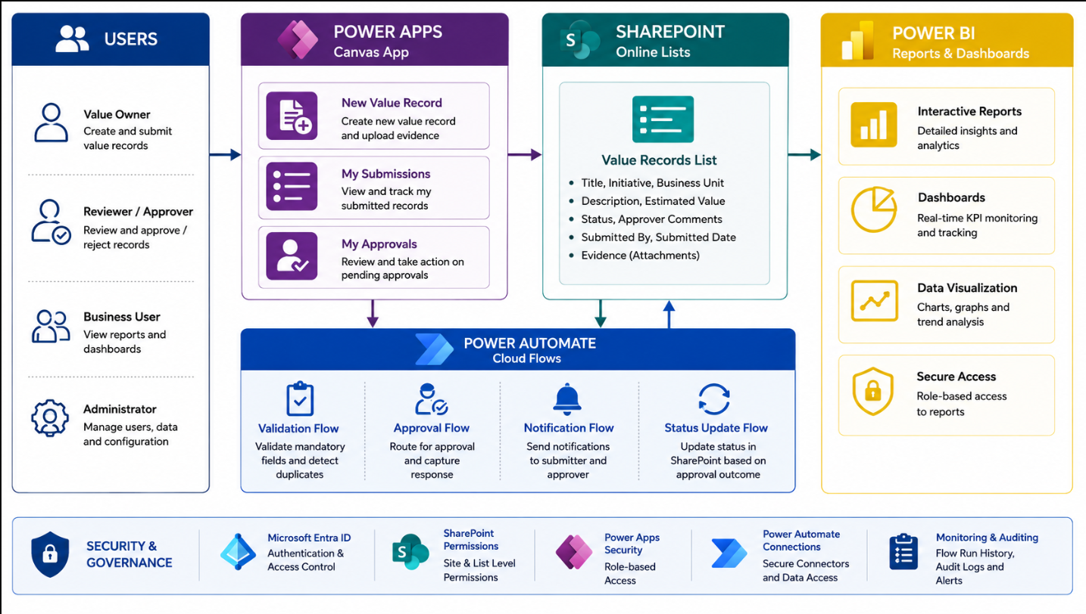
Figure 1: VRMS Reference Architecture (conceptual)
The reference architecture illustrates the end-to-end flow: Users → Power Apps (Canvas App) → SharePoint Online (Value Records List) → Power Automate (Cloud Flows) → Power BI (Reports & Dashboards), with Security & Governance applied across Microsoft Entra ID, SharePoint permissions, Power Apps security, Power Automate connections, and monitoring/auditing. The final architecture, component responsibilities, data flows, security design, and reporting boundaries are subject to Gate 1 approval.

3. Technical Scope & Environment

3.1 Technical Scope
The technical scope enhances the existing RVCO Commercial Value Add SharePoint solution using Company-approved SharePoint Online, Microsoft Lists, Power Apps, Power Automate, Microsoft Entra ID, Power BI enablement, and approved AI capabilities. It comprises:
- The approved data model for value records, reference data, formula and baseline libraries, allocation rules, workflow configuration, supporting evidence, AI recommendation evidence, and audit history.
- Configuration of value-record forms, role-based experiences, workflows, validations, calculations, allocations, notifications, reminders, escalations, delegation, reassignment, return, rejection, closure, reopening, and exception handling.
- AI-assisted recommendation configuration integrated with controlled vocabularies.
- Reporting-ready data structures, mappings, measure definitions, reconciliation logic, operational views, and Row-Level Security requirements for Company-owned Power BI reporting.
- Access controls, segregation of duties, monitoring, administrative capabilities, and audit history.
- Consultant testing, support for Company-led UAT, deployment and rollback preparation, training and documentation, hypercare and first-cycle support, and transition.
Excluded (unless approved). Unapproved platform replacement, new database platforms, premium/custom connectors, third-party services, external hosting, additional licensing, external processing, recurring services, or new site architecture — unless Company expressly approves the item through the applicable architecture, security, commercial, and change-control process.

3.2 Assumptions
- Data received from source and reference systems is complete, accurate, and validated; the solution performs configured validation but not source-level data cleansing beyond approved checks.
- Required Power Platform environments, SharePoint sites, licenses currently available to Company, identities, service accounts, and test access are provisioned according to the integrated schedule.
- SharePoint Online and Microsoft Lists are the Base-Scope operational data platform unless Company approves an alternative.
- Business rules, formulas, baselines, allocation, and reconciliation logic are provided and validated by the Company functional/business team and confirmed at Gate 1.
- AI licensing, service, connector, consumption, external-processing, hosting, and recurring-cost requirements are disclosed and approved before Gate 1.
- Power BI dashboard and semantic-model development is owned by Company Dashboarding; VRMS provides reporting enablement.

3.3 Dependencies & Prerequisites
- Power Platform environment(s) provisioned (for example, a dedicated development environment separate from production).
- SharePoint Online site provisioned for the solution, with owner/member access to create lists and set permissions.
- Microsoft Entra ID accounts and security groups available for all personas (Value Owner, Reviewer/Approver, Business User, Administrator, and service identities).
- Power Apps and Power Automate licensing covering all participants; Approvals connector available (standard connector, no premium license required).
- Connectivity and permissions for SharePoint, Approvals, and the selected notification connector (Outlook or Teams).
- Approved reference/master data (controlled vocabularies, formulas, baselines, allocation and routing rules) available for configuration.

3.4 Licensing & Access
Requirement | Detail
Power Apps license | Per-user or per-app plan covering all participants (submitter, approver, developer).
Power Automate license | Included with most Power Apps plans; the Approvals connector is a standard connector and requires no premium license.
SharePoint Online site | A dedicated site for the solution (for example, /sites/VRMS).
Microsoft Entra ID accounts | Accounts and security groups for at least one submitter and one approver, extended to all approved personas.
Environment | A dedicated Power Platform environment separated from production to avoid affecting other apps.
Table 3: Licensing & Access

3.5 Environment Strategy
The solution is delivered across separate Power Platform environments to isolate development, testing, and production and to support controlled promotion of changes. Final environment names, regions, and promotion controls are confirmed with Company IT at Gate 1.
Environment | Purpose | Access
DEV — Development | Active development and unit testing of apps and flows in an isolated environment (e.g., a Sandbox/Developer environment). | Developers / Engineers
TEST / QA | Functional and integration testing of the application, flows, validations, and reporting-enablement structures. | QA / Test team
UAT | Company-led business validation of functional requirements and data accuracy before release. | Business Users / SMEs
PROD — Production | Live operational environment serving business users, with controlled release. | Operations / Support
Table 4: Environment Strategy

3.5.1 Environment Setup Steps
The following steps establish the development environment and site, following the POC implementation pattern:
Step | Action | Configuration
3.5.1.1 | Create the Power Platform environment | In the Power Platform Admin Center, create an environment (e.g., “VRMS-DEV”); Type: Sandbox or Developer; Region: Company tenant default. Dataverse remains off for the SharePoint-based Base Scope unless Company approves Dataverse.
3.5.1.2 | Create the SharePoint site | In the SharePoint Admin Center, create a Team site (e.g., “VRMS”); record the site URL; add participant accounts as Site Members.
3.5.1.3 | Provision identities & groups | Create/confirm Microsoft Entra ID accounts and security groups for each approved persona and service identity.

3.6 Naming Conventions
Solution artifacts follow a consistent naming convention to keep the solution supportable and to keep Power Apps and Power Automate formulas readable. During the POC, artifacts are prefixed with “POC-” to make them easy to identify and clean up (for example, POC-ValueRecords list, POC-ValueRecordApp app, POC-ValidationFlow flow). For the full build, a Company-approved production naming standard is applied. Column internal names are kept close to their display names (avoiding spaces that trigger _x0020_ suffixes) to keep formulas readable.

3.7 Software & Platform Prerequisites
S. No | Component | Detail
1 | Power Platform | Power Apps (Canvas), Power Automate (Cloud Flows), Power Platform Admin Center.
2 | Microsoft 365 | SharePoint Online, Microsoft Lists, Office 365 Outlook and/or Microsoft Teams.
3 | Identity | Microsoft Entra ID (accounts, security groups, service identities).
4 | Reporting | Power BI Desktop (development) and Power BI Service (publication — Company Dashboarding).
5 | AI Service | Company-approved AI service integrated via approved connector/orchestration (TBC at Gate 1).
6 | Connectors | SharePoint (standard), Approvals (standard), Outlook/Teams (standard).
Table 5: Software & Platform Prerequisites

4. Data Architecture

4.1 Scope
SharePoint Online and Microsoft Lists are the approved Base-Scope operational data platform. Value records are stored in a SharePoint list that serves as the system of record. The data design also covers reference/master data, formula and baseline libraries, allocation rules, workflow configuration, supporting evidence, AI-recommendation evidence, and audit history. Volume, attachment/evidence volume, usage and query patterns, indexing, platform thresholds, and measurable performance requirements are documented and validated during design.

4.2 Value Records List Schema
The core value-record list is the system of record for the value-record lifecycle. The POC list schema below establishes the base structure; the full build extends it with the Company-approved value-tree classification, formula/baseline, allocation, calculation-input, reconciliation, and audit fields confirmed at Gate 1.
Column Name | Type | Required | Notes
Title | Single line of text | Yes | Value-record short name / ID (default SharePoint column).
Initiative | Choice | Yes | e.g., Crude Optimization, Yield Improvement, Energy Efficiency, Scheduling, Logistics, Blending.
BusinessUnit | Choice | Yes | e.g., Refining, Logistics, Blending, Maintenance (aligned to MPC’s org).
Description | Multiple lines of text | Yes | Plain text.
EstimatedValue | Currency | Yes | USD; display-only in the POC (no calculation engine).
Status | Choice | Yes | Draft, Submitted, Validated, Pending Approval, Approved, Rejected. Default: Draft.
SubmittedBy | Person | System-set | Auto-populated by the app on submit.
SubmittedDate | Date and Time | System-set | Auto-populated by the app on submit.
ApproverComments | Multiple lines of text | No | Populated by the approval flow from the reviewer’s response.
Evidence | Attachment | No | Native SharePoint list attachment field.
Table 6: POC Value Records List Schema
Build steps. Create the list (e.g., “Value Records”) in the VRMS site; add each column per the schema; set the Status default to “Draft”; keep attachments enabled; keep column internal names aligned to display names.

4.3 Reference, Master & Configuration Data
Controlled vocabularies, formulas, baselines, allocation rules, routing rules, notification recipients, deadlines, and other administratively maintained configuration are stored in dedicated SharePoint lists (or approved configuration stores) so they can be maintained by administrators without code changes. Named owners, approved versions, and effective dates are established for controlled reference content, with change control and regression-testing requirements. The specific reference lists and columns are confirmed at Gate 1.

4.4 Evidence & Audit
Supporting evidence is captured via native SharePoint attachments (and approved storage/metadata treatment for larger volumes). Audit history retains actor, action, timestamp, affected record, prior state, new state, and comments where applicable — covering value records, workflow actions, calculations, allocations, AI recommendations, user overrides, approvals, corrections, and administrative changes.

4.5 Retention & Archival
Retention, archival, historical access, reporting continuity, reconciliation, and record-disposition requirements are documented during design. Archiving and retention are implemented only if approved by Company and only in a manner that preserves required reporting, auditability, historical access, and reconciliation. Specific retention periods and archival mechanisms are TBC at Gate 1.

5. Application Layer — Power Apps

5.1 Application Creation
The value-record experience is a Power Apps canvas application (Tablet format) connected to the SharePoint Value Records list. The application is created in the target Power Platform environment, and the SharePoint list is added as a data source.
- In Power Apps, confirm the target environment is selected.
- Create → Blank app → Canvas → Tablet format; name it (POC: POC-ValueRecordApp).
- On the Data pane, add a SharePoint data source and connect to the Value Records list.

5.2 Screen 1 — New Value Record
Purpose: lets a Value Owner create and submit a new record. The recommended implementation uses a Power Apps Edit form bound to the Value Records list (DataFields: Initiative, BusinessUnit, Description, EstimatedValue, plus a native Attachments card), which manages create/patch and attachments automatically.
Control | Name | Key Property / Formula
Drop down | ddInitiative | Items: ["Crude Optimization","Yield Improvement","Energy Efficiency","Scheduling","Logistics","Blending"]
Drop down | ddBusinessUnit | Items: ["Refining","Logistics","Blending","Maintenance"]
Text input (multiline) | txtDescription | Default: Blank(); Mode: Multiline
Text input | txtEstimatedValue | Format: Number
Attachment control | attEvidence | Bind to the Evidence field via the form Attachments card.
Button | btnSubmit | OnSelect: see formula below.
Table 7: New Value Record — Controls
btnSubmit — OnSelect
SubmitForm(frmNewValueRecord); Notify("Value record submitted", NotificationType.Success); Navigate(scrMySubmissions, ScreenTransition.Fade)
frmNewValueRecord — OnSuccess
Patch(
'Value Records', frmNewValueRecord.LastSubmit,
{ Status: "Submitted", SubmittedBy: User(), SubmittedDate: Now() }
)

5.3 Screen 2 — My Submissions
Purpose: shows the current user their own records and live status. A vertical gallery is filtered to the current user; labels display Title, Initiative, Status, and SubmittedDate, and the Status label is color-coded.
Gallery — Items
Filter('Value Records', SubmittedBy.Email = User().Email)
Status label — Color (inside gallery template)
If(ThisItem.Status = "Approved", ColorValue("#2E7D32"),
ThisItem.Status = "Rejected", ColorValue("#C62828"),
ColorValue("#B25E00"))

5.4 Screen 3 — My Approvals
Purpose: lets a Reviewer/Approver see records awaiting action and approve or reject them. A gallery is filtered to records pending approval; selecting an item navigates to a Detail screen showing full record details and evidence, with Approve and Reject buttons.
Gallery — Items
Filter('Value Records', Status = "Pending Approval")
btnApprove — OnSelect
Set(varAction, "Approve"); 'ApprovalResponseFlow'.Run(ThisItem.ID, "Approved", txtComments.Text); Notify("Approval recorded", NotificationType.Success); Navigate(scrMyApprovals, ScreenTransition.Fade)
btnReject — OnSelect
Set(varAction, "Reject"); 'ApprovalResponseFlow'.Run(ThisItem.ID, "Rejected", txtComments.Text); Notify("Rejection recorded", NotificationType.Success); Navigate(scrMyApprovals, ScreenTransition.Fade)
The ApprovalResponseFlow is a Power Automate flow with a Power Apps trigger, called directly from the app (Section 6.5). Add it via Data → Add data → Flows before referencing it in a formula.

5.5 Navigation
A simple left navigation or top tab bar provides three items — New Record, My Submissions, My Approvals — using Navigate(scrX, ScreenTransition.Fade) on each nav button’s OnSelect. For the full build, navigation, screens, queues, and administrative experiences are extended per the approved role model and field-level access matrix.

6. Workflow Layer — Power Automate
Power Automate cloud flows implement the deterministic automation supporting the human governance workflow. The POC establishes four flows for the core lifecycle; the full build extends these with Company-approved routing, calculation/allocation/reconciliation support, record locking, archiving/retention, escalation, and exception handling. Flows are built in the target (isolated) environment.

6.1 Workflow Overview
Flow | Purpose
Validation | Checks mandatory fields and flags likely duplicates on submission.
Workflow Routing & Decisions | Routes records through approved review, endorsement, approval, return, rejection, reassignment, delegation, closure, reopening, escalation, and exception paths per the approved workflow and role model.
Calculation, Allocation & Reconciliation Support | Supports approved calculation, allocation, reconciliation, exception, and correction processes per approved business rules and field-level permissions (full build).
Record Locking & Status Management | Locks, unlocks, reopens, updates, closes, or changes record status per approved workflow, security, auditability, and administrative controls.
Notification | Configurable notifications, reminders, escalations, and overdue visibility through approved channels; timing, events, recipients, content, and suppression rules are administrable where approved.
Archiving & Retention | Implemented only if approved, preserving required reporting, auditability, historical access, and reconciliation (full build).
Table 8: Cloud Flow Inventory

6.2 Flow 1 — Validation Flow
Trigger: automatically when a new item is created in the Value Records list.
Step | Action | Configuration
1 | Trigger — When an item is created | Site: VRMS; List: Value Records.
2 | Condition — Mandatory fields present | Check Initiative, BusinessUnit, Description, EstimatedValue are not blank.
3a | If Yes — Get items (duplicate check) | Query Value Records where Title = trigger Title and ID ≠ trigger ID.
3b | Condition — Duplicate found? | If count > 0 → set Status = "Submitted" and append "Possible duplicate" to ApproverComments; else → set Status = "Validated".
4 | If No (missing fields) | Set Status = "Draft"; notify the submitter (Teams/Outlook) listing the missing fields.
Table 9: Validation Flow

6.3 Flow 2 — Approval Routing Flow
Trigger: automatically when an item’s Status changes to "Validated" (via a trigger condition, or a Condition action after an "On item modified" trigger).
Step | Action | Configuration
1 | Trigger — When an item is modified | List: Value Records; Trigger condition: Status eq 'Validated'.
2 | Update item | Set Status = "Pending Approval".
3 | Start and wait for an approval | Type: Approve/Reject — First to respond; Assigned to: designated approver; Title includes Initiative and EstimatedValue.
4 | Condition — Outcome | If Approve → branch 5a; if Reject → branch 5b.
5a | Update item | Status = "Approved"; ApproverComments = approval response comments.
5b | Update item | Status = "Rejected"; ApproverComments = approval response comments.
6 | Send email / Teams message | Notify SubmittedBy of the final outcome and comments.
Table 10: Approval Routing Flow

6.4 Flow 3 — Status Update & Notification
For the POC, the status-update and notification behavior is folded into the end of the Approval Routing Flow (steps 5a/5b/6) to keep the flow count small. It is split into a separate flow only if strict single-responsibility flows are preferred, and is extended in the full build with configurable reminders, escalations, and overdue visibility.

6.5 Flow 4 — Approval Response Flow
This flow is called directly from the Power Apps Approve/Reject buttons (Section 5.4) as a faster in-app path that does not wait on the Teams/Outlook approval card — useful for the in-app demo experience.
Step | Action | Configuration
1 | Trigger — Power Apps (V2) | Input parameters: RecordID (number), Decision (text), Comments (text).
2 | Get item | Value Records, ID = RecordID.
3 | Update item | Status = Decision; ApproverComments = Comments.
4 | Send email / Teams message | Notify the record’s SubmittedBy of the outcome.
5 | Respond to Power Apps | Return Status: "OK" so the app can show a confirmation.
Table 11: Approval Response Flow

6.6 Connection References
- Use the SharePoint connector (standard) for all list actions.
- Use the Approvals connector for the approval step in the Approval Routing Flow.
- Use the Office 365 Outlook or Microsoft Teams connector for notifications — pick one consistently across flows.

6.7 App-to-Flow Integration
The application is connected to the Approval Response Flow so the in-app Approve/Reject buttons can invoke it:
- In Power Apps Studio, open the app and go to Data → Add data → Flows → select the Approval Response Flow.
- Confirm the flow appears in the app’s data sources.
- Verify the btnApprove/btnReject formulas reference the flow by its exact name; Save and Publish the app.
- Note: Power Apps auto-generates the .Run() parameter signature from the flow’s Power Apps trigger inputs — if the input parameters change, republish the app or the call signature will break.

7. AI-Assisted Value Classification
VRMS integrates a Company-approved AI service with the value-record form and controlled vocabularies to recommend applicable Value Realization classifications and calculation references. AI-assisted classification is part of the Base Scope and is not a separate later phase. (Note: the core-lifecycle POC deliberately excludes AI classification; this section defines the full-build technical design.)

7.1 Recommendation Scope
Based on the information entered or attached to a value record and the approved reference content, the capability recommends — where sufficient information exists — value chain stage, value chain subcategory, value lever, standardized action, applicable formula archetype or approved formula, and applicable baseline or baseline category. Recommendations are limited to Company-approved controlled vocabularies, formulas, baselines, standardized actions, and reference content.

7.2 Data & Knowledge Controls
The technical design documents the inputs evaluated by the AI capability; the approved reference documents and structured reference data used; controlled vocabularies and version management; the AI services, models, prompts, orchestration, connections, and environments used; the data transmitted to each AI service and where processing occurs; data retention, logging, monitoring, access control, and deletion treatment; whether any service retains prompts, responses, feedback, or Company data; and all licensing, connector, consumption, hosting, and recurring costs. Company data is not used for external model training, third-party product improvement, benchmarking, or unrelated purposes without written Company authorization. Specific AI service, connector, and processing-location decisions are TBC at Gate 1.

7.3 Confidence & Exception Handling
The design establishes Company-approved confidence bands and expected behavior for each band. Low-confidence, conflicting, incomplete, unsupported, or ambiguous recommendations are clearly identified and routed for human selection or governed exception handling. Confidence indicators are not represented as probabilities of business correctness unless the selected method supports that interpretation and Company approves its use.

7.4 Auditability
For each recommendation, the solution retains the record identifier, relevant input or input reference, recommendation, classification level, confidence indicator, explanation or reason code, applicable model or configuration version, user disposition, final selected value, user, and timestamp.

7.5 Conceptual AI Architecture
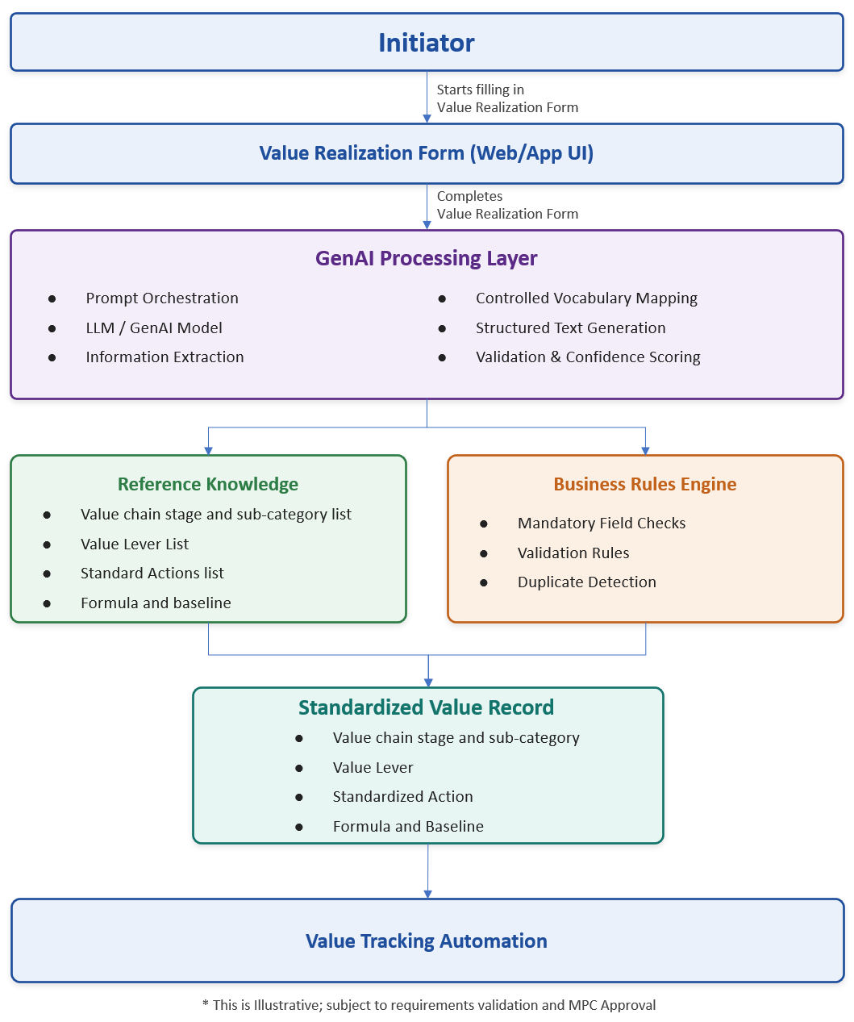
Figure 2: Conceptual AI-Assisted Value Classification Architecture (illustrative; subject to requirements validation and MPC approval)

7.6 Fail-Safe & Testing
AI assistance fails safely: core value-record creation, deterministic validation, calculation, allocation, workflow, reconciliation, and reporting-enablement functions remain usable if the AI capability is unavailable. Before production deployment, a Company-approved representative test set is developed; acceptance thresholds are established by recommendation type at Gate 1; and recommendation quality, controlled-vocabulary compliance, incomplete/ambiguous inputs, unsupported requests, confidence behavior, user override, security, audit logging, performance, availability, and fallback are tested, with observed errors and corrective actions documented and retested.

8. Reporting Enablement & Power BI
VRMS delivers reporting-ready views and datasets derived from the SharePoint operational data; Company Dashboarding owns building, publishing, and administering the final Power BI reports. Power BI connects to the reporting-ready data using approved connectivity and Import mode, applies the approved semantic model and DAX measures, and enforces Row-Level Security.

8.1 Reporting Data Sources
Data Source | Type | Connection Mode
SharePoint Online — Value Records list | SharePoint | Import
SharePoint Online — Reference/Configuration lists | SharePoint | Import
Reporting-ready views / datasets (as approved) | SharePoint / approved store | Import
Table 12: Reporting Data Sources

8.2 Reporting Design & Content
The reporting-enablement design provides the source structures, mappings, measure definitions, reconciliation logic, reporting states, and security requirements Company Dashboarding needs to build and validate reports without recreating VRMS-developed logic.
Reporting Item | Required Content
Reporting requirements | Audiences, report categories, dimensions, filters, reporting states, operational/executive/exception views, AI monitoring needs, and required outputs.
Source-field mapping | Source field, data type, business definition, transformation, owner, security treatment, and report usage.
KPI & measure definitions | Calculation logic, included/excluded records, aggregation, tolerance, owner, reporting state, and reconciliation approach.
Reconciliation logic | Source-to-report checks, expected results, exceptions, correction process, and sign-off requirements.
Security requirements | Row-Level Security approach, access groups, role assumptions, access boundaries, and access-testing evidence.
AI reporting requirements | Recommendation volumes, confidence distribution, acceptance/override rates, exceptions, and unresolved low-confidence items.
Handoff documentation | Sufficient for Company Dashboarding to build, validate, publish, administer, and support assigned Power BI outputs.
Table 13: Reporting Enablement Content

8.3 Row-Level Security
Row-Level Security, default views, role-based report behavior, executive views, administrative views, and access boundaries are validated and approved by Company before implementation. RLS aligns with the same Microsoft Entra ID role model applied across SharePoint and Power Apps. Specific KPI/measure definitions and RLS roles are finalized with Company at Gate 1.

9. Security & Access Design
Role-Based Access Control is implemented through Microsoft Entra ID security groups mapped to Company-approved roles and personas, applied consistently across SharePoint site permissions, the Power Apps application, and Power BI Row-Level Security. Segregation of duties is enforced (for example, an Initiator cannot approve their own record). Business-role authority and technical administration are treated separately.
Security Domain | Control / Description
Identity & Access | Microsoft Entra ID authentication; RBAC security groups mapped to approved roles/personas; applied across SharePoint, Power Apps, and Power BI.
Segregation of Duties | Workflow-enforced separation (Initiator ≠ Approver); separation of business-role authority from technical administration.
Least Privilege | AI service identities, application identities, connections, and service accounts use least privilege and are monitored.
Access Lifecycle | Provisioning, role changes, temporary access, delegation, reassignment, periodic access review, privileged access controls, deprovisioning, and access removal.
Data-in-Transit | TLS/HTTPS enforced by the Microsoft 365 / Power Platform service endpoints.
Secret Management | Connection credentials and any secrets managed through approved Power Platform connection references / Company secret management; no hard-coded credentials.
Auditability | Material audit history across value records, workflow actions, calculations, allocations, AI recommendations, overrides, approvals, corrections, and administrative changes.
Table 14: Security & Access Controls
Access-control testing. Testing includes role-based access, least privilege, segregation of duties, administrative access, reporting access, and attempted unauthorized access, validated before production deployment.

10. Monitoring & Error Handling
- Flow failures are monitored via Power Automate run history; errors are logged, triaged, and resolved.
- Detailed logging is maintained at key steps for diagnosis and resolution.
- Transient failures use configurable retry where supported by the connector/action; production-grade error handling and retry logic are part of the full build (the POC keeps error handling minimal).
- Notifications alert operations/support of failures requiring attention.
- Audit history and flow run history together support operational monitoring and troubleshooting.

11. Deployment & Release Management
Solution artifacts (apps, flows, lists, and configuration) are promoted across environments (DEV → TEST/QA → UAT → PROD) using Company-approved release practices — for example, Power Platform solutions/managed packaging and configuration migration, with environment-specific connection references. Any proposed use of Azure Repos, Git, Kanban tools, Azure Pipelines, service accounts, connectors, environments, or CI/CD methods requires applicable Company review and approval before use. Cutover, rollback, release, and validation plans are prepared and approved before production deployment.
S. No | Pipeline / Method | Environment | Description
1 | Solution export/import (or approved ALM) | DEV → TEST/QA | Promote app, flows, and configuration for functional/integration testing. (To be finalized at Gate 1.)
2 | Solution export/import (or approved ALM) | TEST/QA → UAT | Promote validated build for Company-led UAT.
3 | Controlled release | UAT → PROD | Production deployment with cutover, rollback, and validation. (To be finalized at Gate 1.)
Table 15: Deployment Approach (to be finalized at Gate 1)

12. Testing & Validation
Requirements-traceable testing covers unit, functional, integration, workflow, security, calculation, allocation, reporting, AI, performance, deployment, rollback, and operational-readiness testing as applicable, followed by Company-led UAT. The core value-record lifecycle test cases below (from the POC pattern) are extended by the full-build test basis approved at Gate 1.
# | Test Case | Steps | Expected Result
1 | Happy-path submission | Submit a complete record as the submitter. | Status moves Draft → Submitted → Validated → Pending Approval automatically.
2 | Missing mandatory field | Submit a record with EstimatedValue blank. | Validation flow sets Status back to Draft and notifies the submitter of the missing field.
3 | Duplicate detection | Submit two records with the same Title. | Second record is flagged as a possible duplicate in ApproverComments.
4 | Approval — approve | As approver, open My Approvals and approve a pending record. | Status becomes Approved; submitter receives a notification.
5 | Approval — reject | As approver, reject a pending record with a comment. | Status becomes Rejected; comment appears in ApproverComments; submitter notified.
6 | My Submissions filter | Log in as submitter A and submitter B. | Each sees only their own records in My Submissions.
7 | Evidence attachment | Attach a file when submitting. | Attachment is visible on the record in SharePoint and in the app’s detail view.
Table 16: Core Lifecycle Test Cases

13. Handover & Transition

13.1 Handover Checklist
- SharePoint Value Records list created with full schema.
- Power Apps app built with all screens and published.
- All flows created, turned on, and tested.
- Test accounts / security groups configured with correct site permissions.
- All core lifecycle test cases passed.
- Findings/feedback log started to capture stakeholder input.
- Environment and artifacts labeled clearly (POC vs. production) to avoid confusion during the full build.

13.2 Stakeholder Demonstration
A short walkthrough demonstrates the end-to-end pattern: creating and submitting a value record with an attachment; the validation flow run history; the record appearing in My Approvals; approving with a comment and the resulting notification; and the validation rejection path for a missing field. Findings from demonstrations feed back into the Solution Design phase of the main VRMS engagement.

Appendix A — Glossary & Acronyms
Term / Acronym | Definition
VRMS | Value Record Management Solution — the Value Tracking Automation capability.
VCO | Value Chain Optimization.
RVCO | The existing Commercial Value Add SharePoint solution/list used to record VCO value events.
POC | Proof of Concept — the validated core-lifecycle build pattern.
Canvas App | A Power Apps application built on a blank canvas with explicit control layout and formulas.
Cloud Flow | A Power Automate automated/instant workflow.
Approvals connector | Standard Power Automate connector providing Approve/Reject approval requests.
RBAC / RLS / SoD | Role-Based Access Control / Row-Level Security / Segregation of Duties.
Entra ID | Microsoft Entra ID — enterprise identity and access management.
ALM | Application Lifecycle Management (solution promotion across environments).
UAT | User Acceptance Testing.
Gate 1–4 | Decision gates authorizing progression across the delivery life cycle.
TBD / TBC | To Be Determined / To Be Confirmed — to be resolved during requirements and design.

